Documentation for Java Image Editor:

**Introduction:**

Java image editor is a program designed for editing or modifying images. It reads an image in the form of pixels and edits them accordingly.

**Image:**

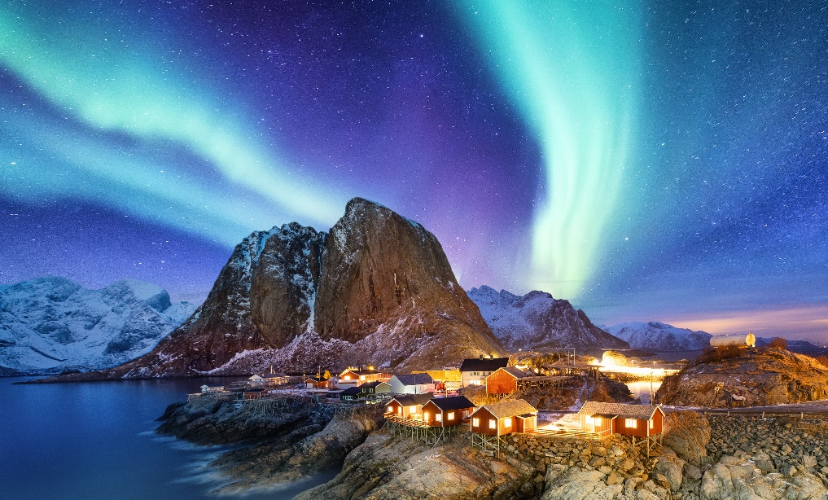

**Features:**

1. *Convert to Gray Scale:*

Description: This feature modifies the colour of the input image to a greyish shade.

Code:

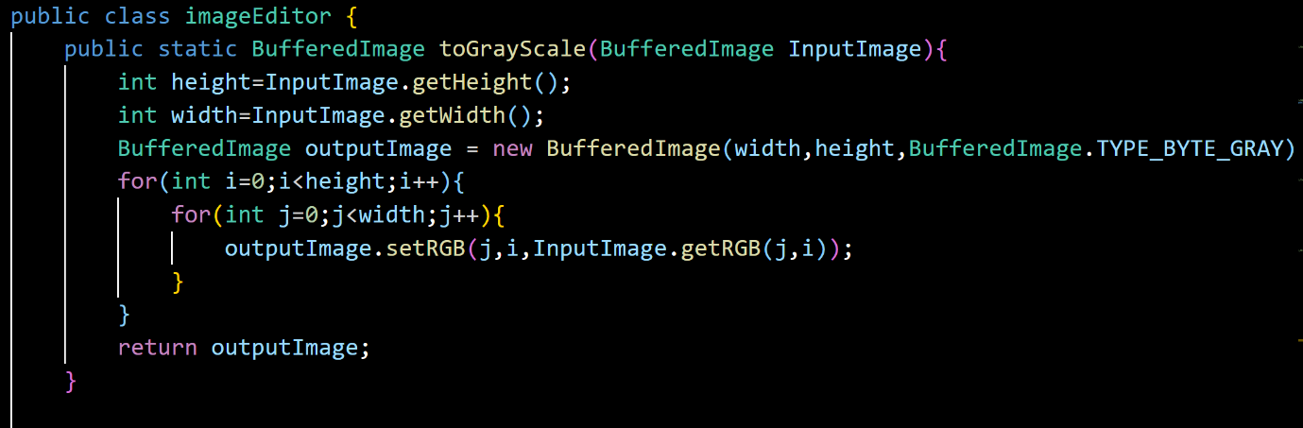

Input Image:

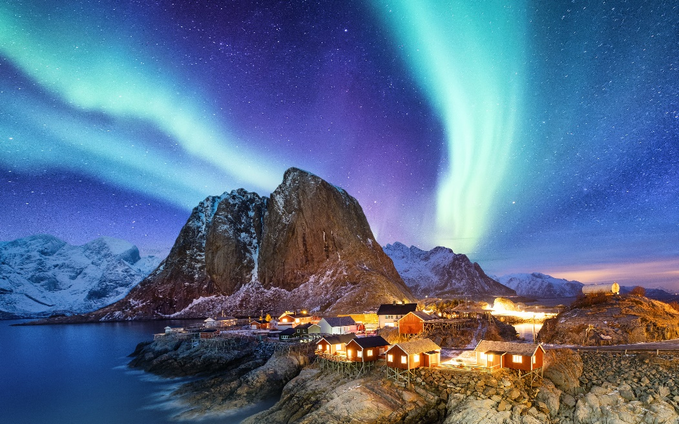

Output image:

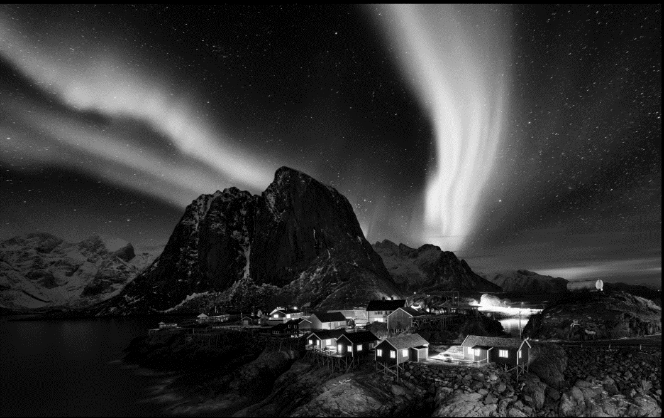

1. *Rotate 90 degrees Clockwise:*

Description: This feature rotates the input image by 90 degrees angle in clockwise direction (right transpose).

Code:

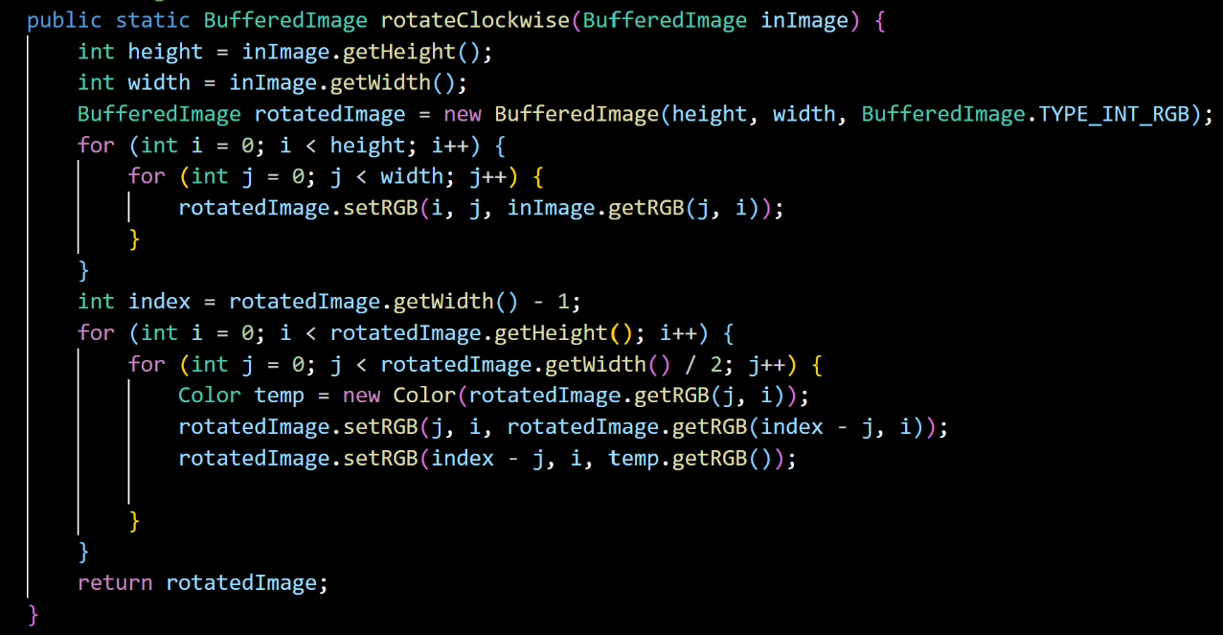

Input Image:

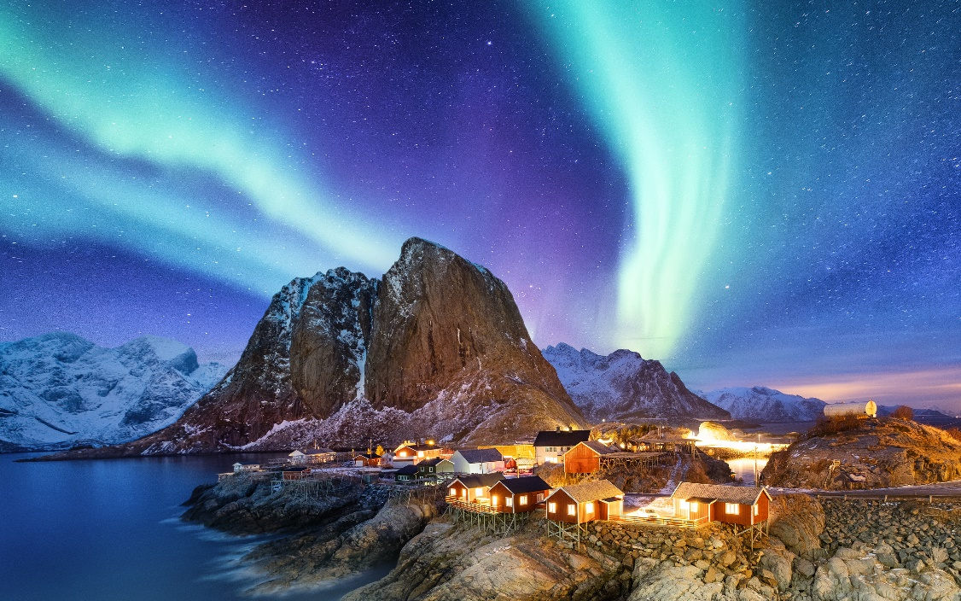

Output Image:

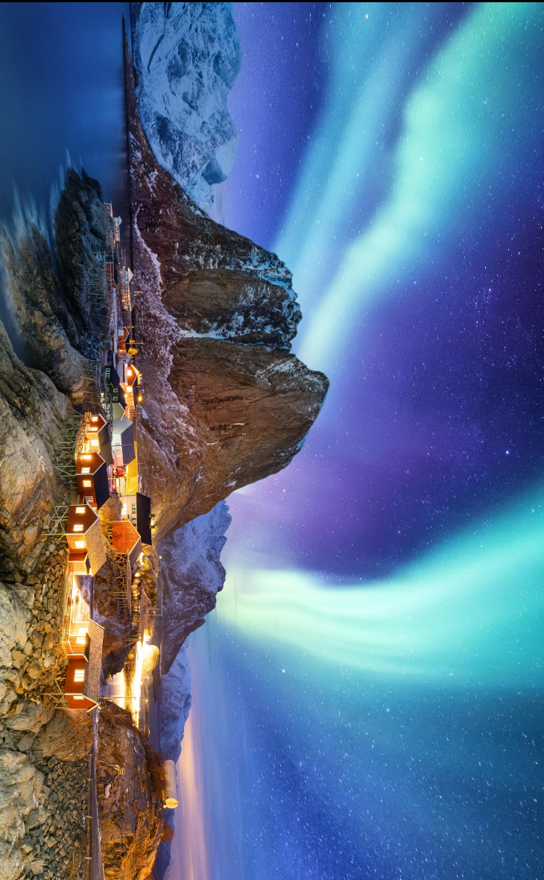

1. *Rotate 90 degrees Anti-Clockwise:*

Description: This feature rotates the input image by 90 degrees angle in anti-clockwise direction (left transpose).

Code:

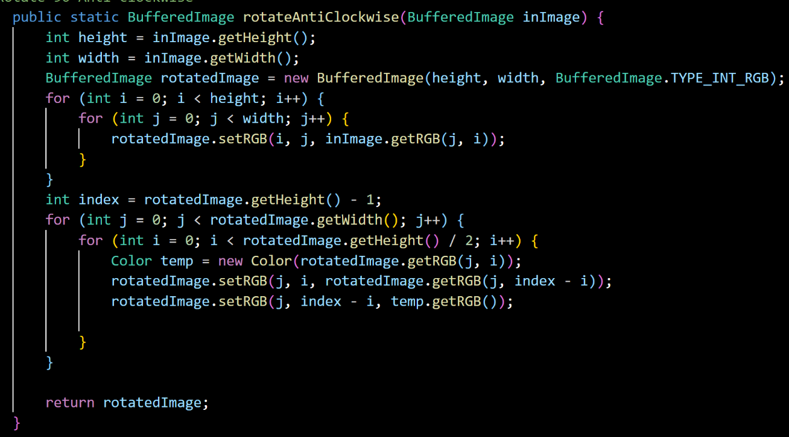

Input Image:



Output Image:

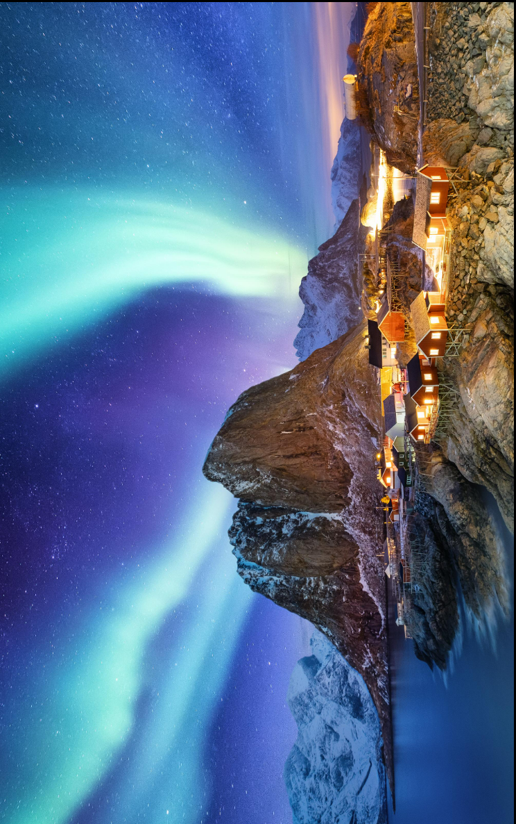

1. *Adjust Brightness:*

Description: By using this feature and specifying the required percentage of brightness you want, you can adjust the brightness of the input image.

Code:

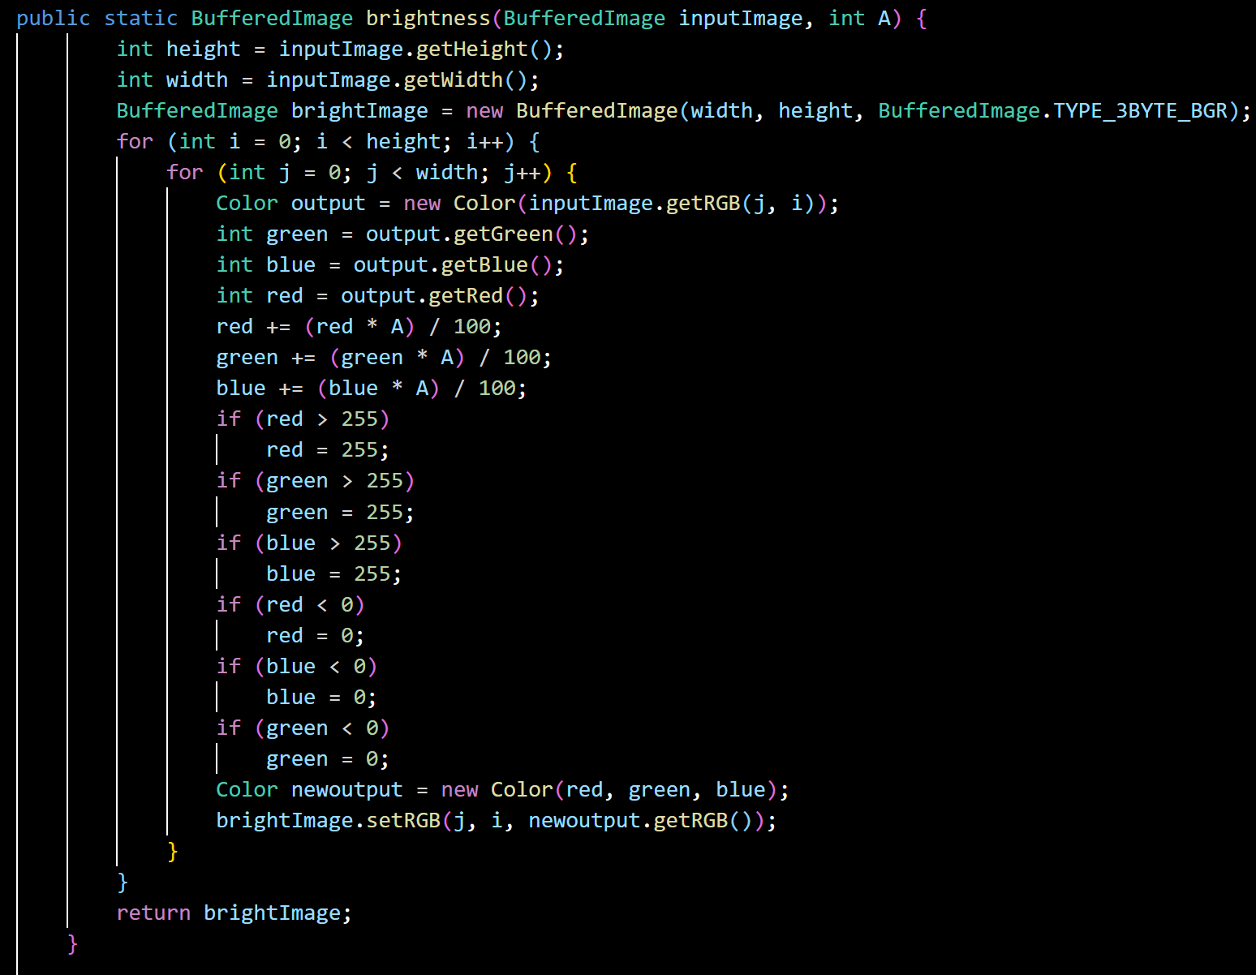

Input Image:



Output Image: (40% brightness)

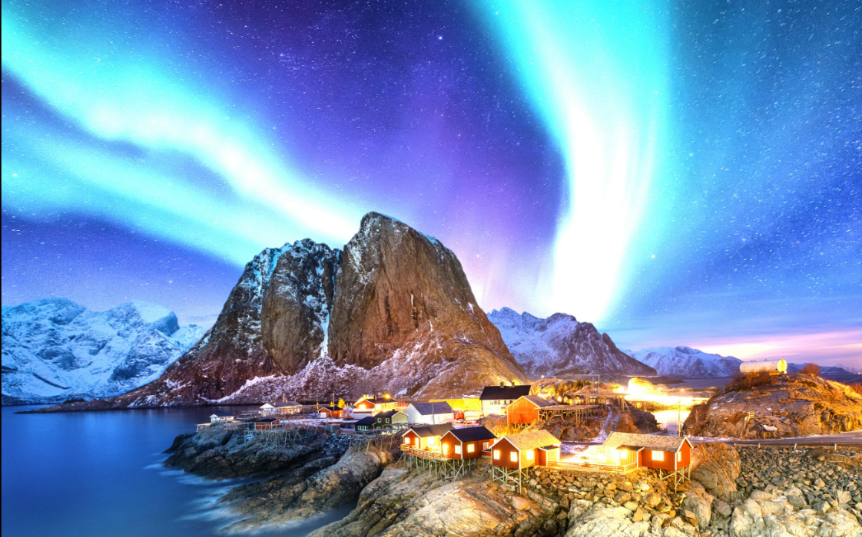

1. *Invert the image:*
2. *Vertical inversion:*

Description: This feature inverts or flips the input image vertically.

Code:

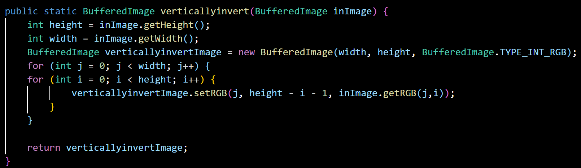

Input Image:



Output Image:

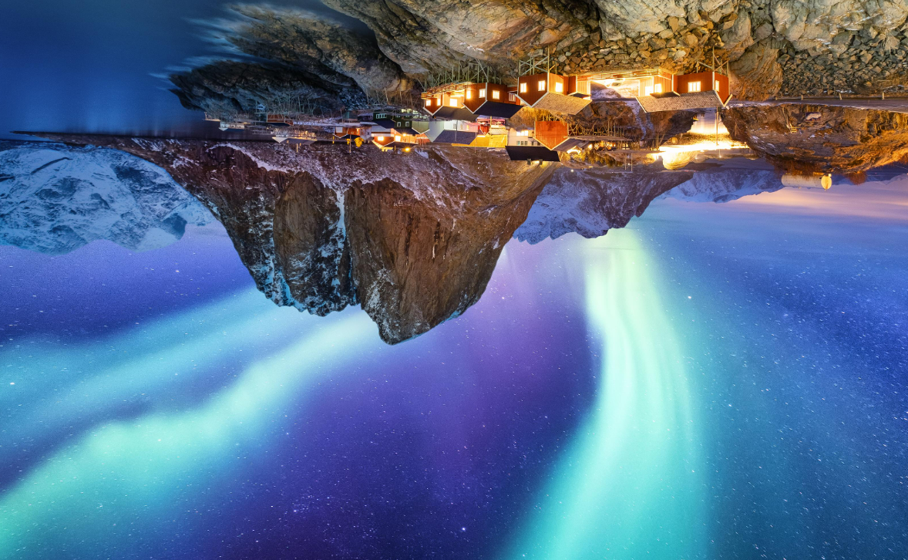

1. *Horizontal inversion:*

Description: This feature inverts or flips the input image horizontally.

Code:

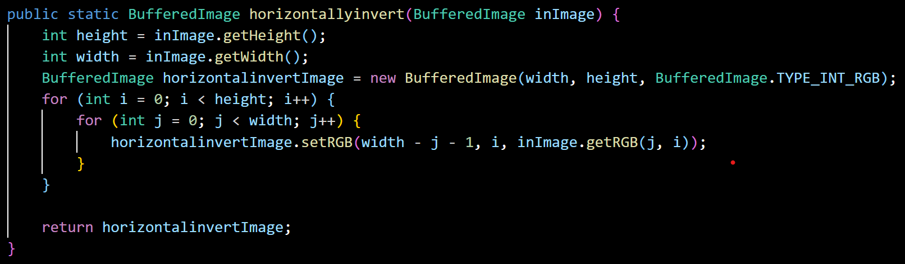

Input Image:

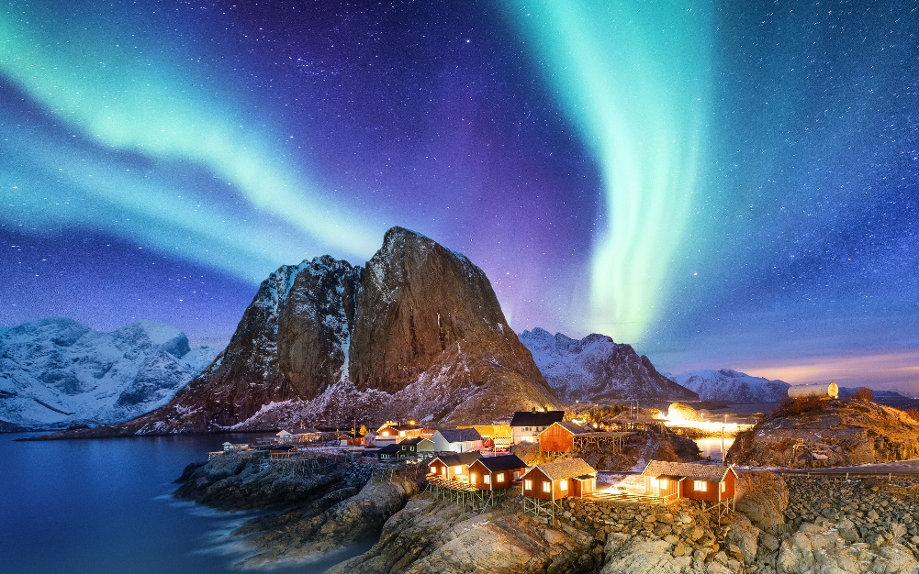

Output Image:

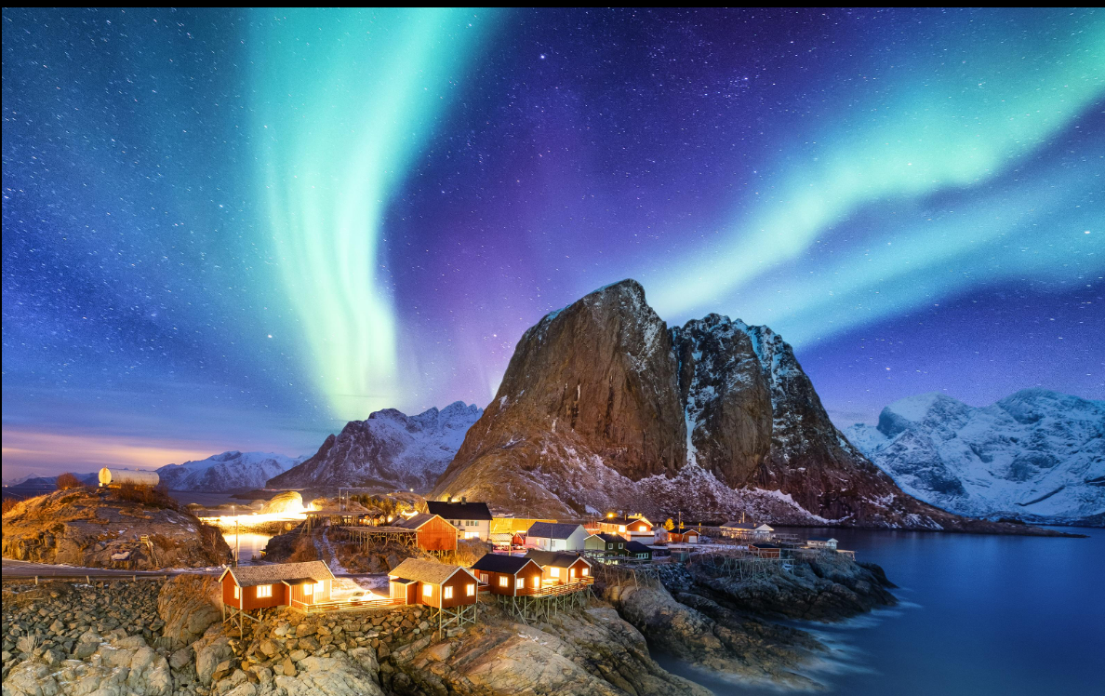

1. *Blur the image:*

Description: This feature adjusts the blurriness of the input image by specified pixel values.

Code:

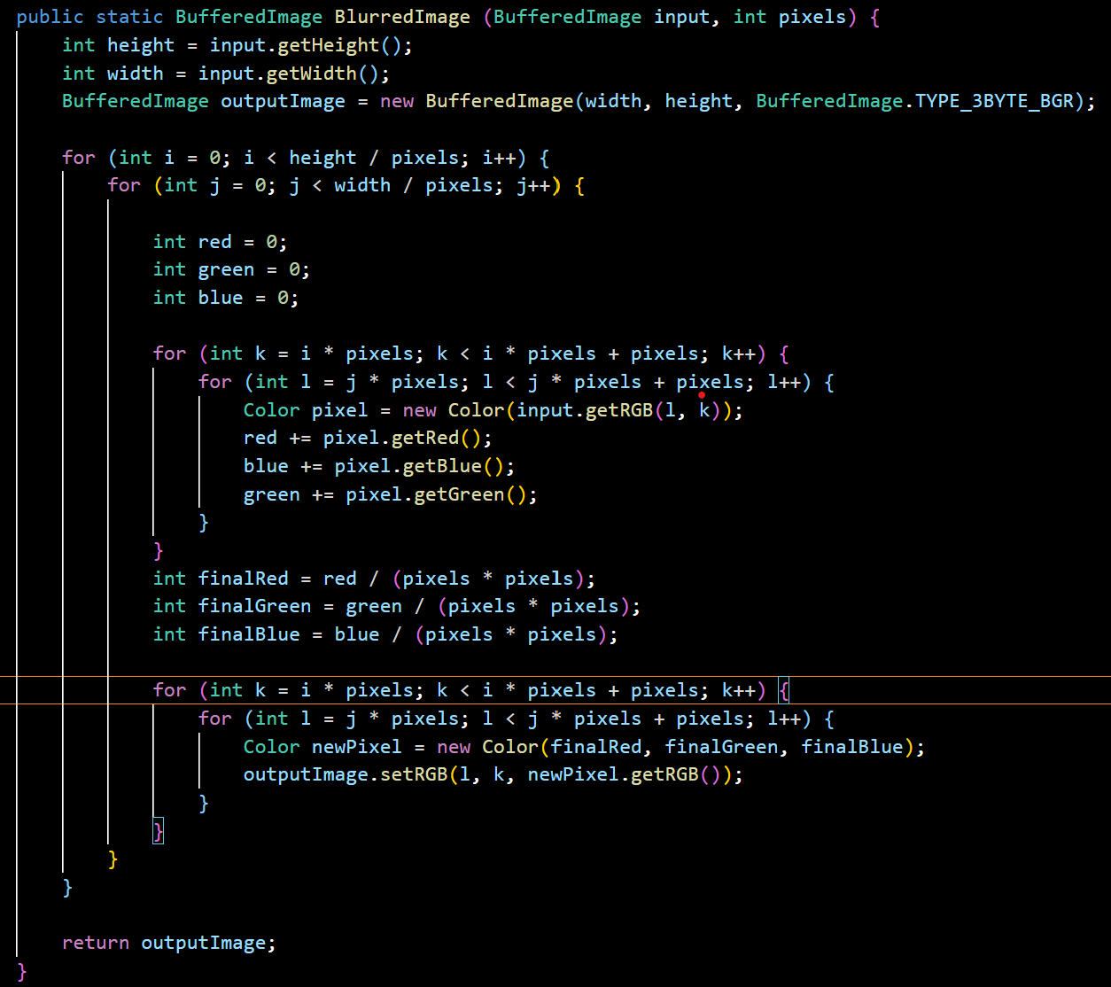

Input Image:



Output Image:

